Ajinomoto Philippines – Supplier Onboarding Requirements
Workshop Day 1 · Oct 26, 2026 · @Srini

1. Workshop context and scope
Ajinomoto Philippines (Project Beacon) needs one system where new raw material and packaging suppliers are accredited, documented and approved end to end, replacing today's email, shared-drive and paper-form process before vendor creation in SAP S/4HANA.
Item | Detail
Client | Ajinomoto Philippines Corporation (APC)
Programme | Project Beacon (Business Excellence through Automation, Collaboration, Optimization Network)
Workshop | Day 1 – Supplier onboarding and accreditation, 26 Oct 2026
Durvah team | Srini, Kishore, Sunit Nighut
Ajinomoto team | Chris Ballesteros (Beacon lead), procurement (Ray, Josh), Sir Jed; IT – Joanna Escanilla, Daryl Ann Malabo, Janine; Joshua Omus
Purpose | Understand the as-is onboarding process to define requirements for selecting a source-to-pay / supplier management platform
In scope (phase 1)
- Direct procurement only: raw materials (RM) and packaging materials (PM).
- New-supplier sourcing, quality assessment, audit, accreditation and vendor creation.
- Sourcing of alternative suppliers for existing materials.
- E-sourcing (RFQ) and a supplier pricing database – confirmed in scope though not shown in the high-level process deck.
Out of scope (phase 1)
- Indirect procurement, services and assets – to follow after phase 1, subject to management decision.
- Market intelligence for finding new suppliers (commodity price tracking follows an Ajinomoto group standard).
Covered in later sessions: supplier audit planning and performance evaluation (QCD), PR-to-PO and delivery scheduling, finance vendor creation, R&D material evaluation.

2. Stakeholders in onboarding
At Ajinomoto, procurement covers buying, quality and material development together, so many functions touch every new supplier.
Function | Role in supplier onboarding
R&D | Raises the need for new materials; issues the specification set and required document list; evaluates samples and trials; decides with procurement whether to continue with a failing supplier
Procurement (head office) | Identifies potential suppliers, sends RFQs, evaluates cost, collects documents, requests audits, signs the vendor request form, awards and issues POs
Quality Assurance (QA) | Reviews technical documents and certifications; leads quality assessment, which includes the audit result
Audit team (APC team, SDMD, procurement, R&D, QA) | On-site audit for local suppliers; remote/document or GSM audit for foreign suppliers via Ajinomoto affiliates
Marketing | Part of the internal product assessment with R&D and QA
Supply planning (SPLDR) | Delivery scheduling; requests creation of new items in SAP
Finance | Creates the vendor master in SAP from the vendor request form; validates banking details
IT | Creates material/item masters in SAP on request; owns integrations (ABAP in-house, third-party vendors for WMS/LIMS)
Factories (2 plants + 1 planned; hub for FG only) | Receive materials; provide quality and delivery inputs for supplier performance (QCD)
Management / department heads | Review accreditation documents; approve the vendor checklist

3. Current-state process (as-is)
Onboarding is item-led: a supplier is only accredited after one of its materials passes cost, trial and quality checks, and every hand-off between teams happens by email.
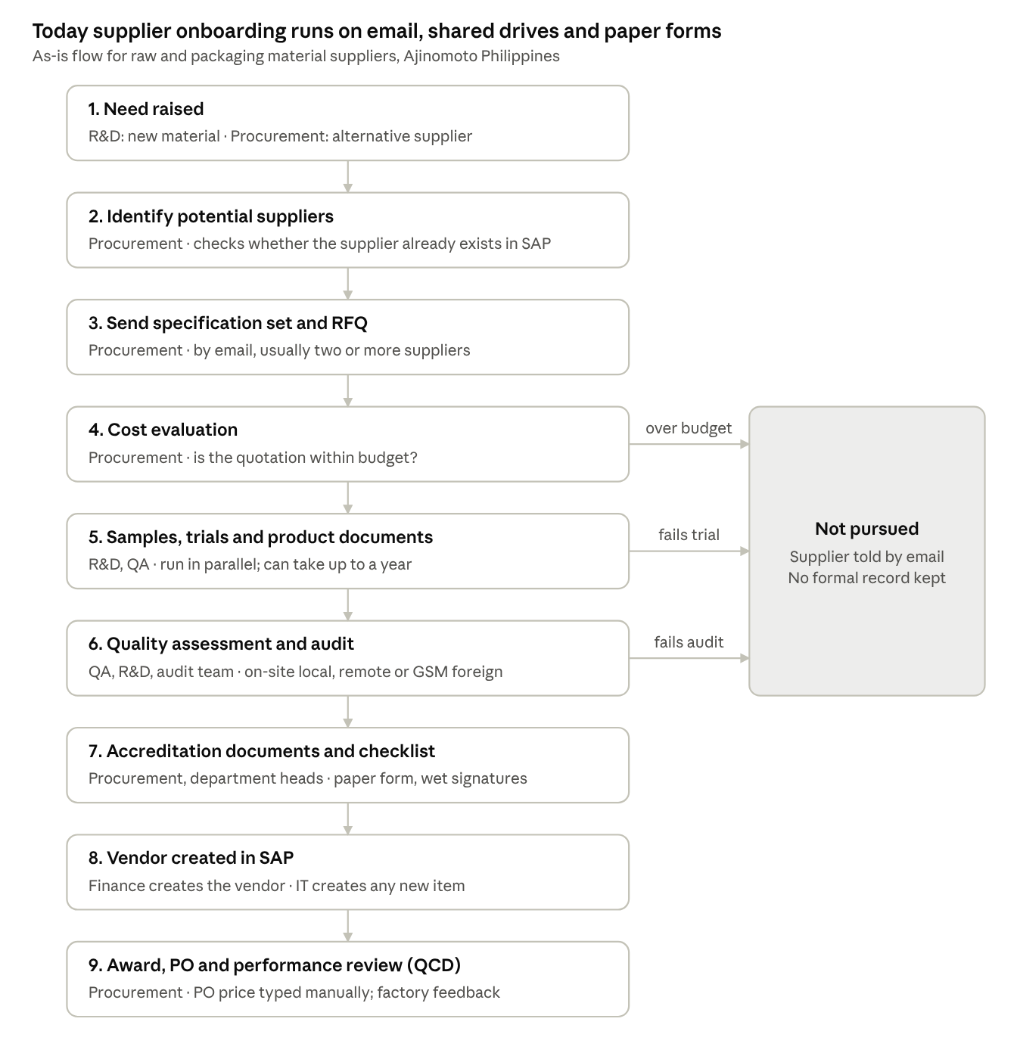
As-is supplier onboarding · 9 steps, 3 exits
Key points from the walkthrough:
- Supplier documents are requested in two rounds: product/technical documents during sourcing, then company documents for accreditation once quality passes.
- Audit is mandatory for new suppliers. For an existing supplier offering a new material, the team decides case by case, because the manufacturing process may differ.
- Accreditation itself rarely fails: suppliers that reach it already hold business permits. Failures happen earlier, in trials or audit.
- For existing materials, procurement runs an annual alternative-sourcing review, driven by the KPI on reducing sole supply and unit cost. Existing accredited suppliers are checked first.
- Indirect POs are sometimes raised by the same team but follow a different, out-of-scope sourcing process.

4. Pain points
The biggest gap is that accreditation happens entirely outside any system: nobody can see a supplier's status or whether its documents are valid.
# | Pain point | Impact
P1 | Documents exchanged by email back and forth between supplier, procurement, R&D, QA and finance; stored in shared drives, not one repository | Long cycle times; documents hard to find and verify
P2 | No status visibility for internal teams or suppliers on assessment and accreditation | Follow-ups by email; suppliers not formally told of pass/fail
P3 | No formal disqualification step – a failed assessment is communicated by email only | No audit trail of rejection decisions
P4 | Document expiry is checked manually | Risk of buying from suppliers with expired certifications
P5 | Paper/Excel vendor request form with wet signatures; suppliers often skip it and attach documents instead | Finance re-keys data; inconsistent master data
P6 | SAP allows the same supplier to be created twice; no unique-ID check (TIN) | Duplicate vendor codes – at least two known cases
P7 | No supplier type classification (local vs foreign) beyond address and currency | Wrong document checklist and bank fields per supplier type
P8 | Approved supplier status is per material but not enforced in SAP – a supplier cannot be blocked for one material only | Risk of ordering a material from a supplier not approved for it
P9 | No price agreements: PO prices are typed manually from the latest quotation; outline agreements exist in SAP but are not used | Repeat RFQs, price errors, procurement effort on every PO
P10 | Quality inspection data sits in QAD/LIMS with no direct link to supplier records | Performance evaluation is manual
Cycle times quoted: accreditation 1–2 weeks once assessment passes; RFQ to award 5 days to 1 month; a new material with a new supplier can take about 1 year because of R&D trials.

5. Future-state process (to-be)
The proposed flow keeps Ajinomoto's assessment gates but moves every document, decision and status update onto one platform, with suppliers working in a portal and SAP receiving only approved suppliers and agreed prices.
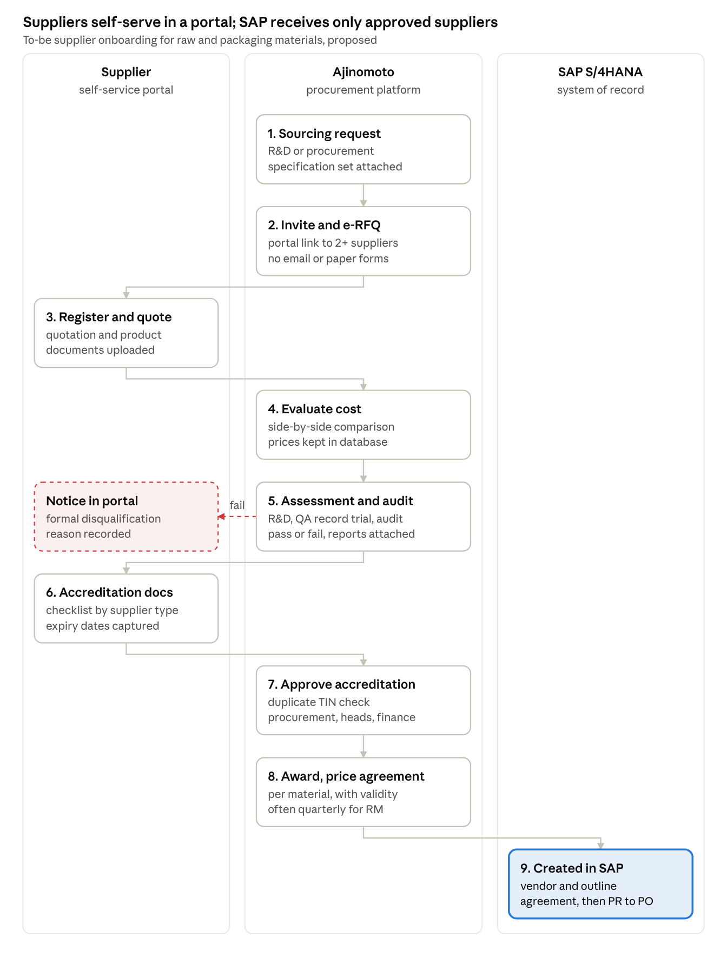
To-be supplier onboarding · 3 lanes, 9 steps
Design principles agreed in discussion:
- Registration is by invitation only; suppliers cannot self-register for RM and PM.
- R&D and QA can run trials and audits outside the system, but record the outcome and reports in it.
- Suppliers see their status at every stage and receive a formal notice if they fail.
- Finance still creates the vendor in SAP, but from approved platform data rather than a re-keyed form.
- Steps 2 to 5 can run in parallel for two or more suppliers on the same material.

6. Functional requirements
Twenty-four requirements came out of Day 1; the must-haves centre on a supplier portal, configurable document checklists and a tracked accreditation workflow ending in SAP vendor creation. Priorities are Durvah's proposal for Ajinomoto to confirm.
ID | Area | Requirement | Priority
SO-01 | Sourcing request | Capture the sourcing need from R&D (new material) or procurement (alternative supplier for existing material) as a tracked request with the specification set attached | Must
SO-02 | Supplier invitation | Procurement invites potential suppliers to a portal by link; no paper forms | Must
SO-03 | Supplier portal | Suppliers self-enter company, contact, tax and bank details and upload documents; pre-checklist blocks submission until mandatory items are present | Must
SO-04 | Registration path | Support invitation-only registration for RM/PM (no open self-registration); registration follows assessment | Must
SO-05 | E-sourcing | Issue RFQs to multiple potential suppliers; capture quotations electronically; cost comparison and evaluation | Must
SO-06 | Product documents | Material-specific document requests (specifications, FDA, certificates) defined by R&D per material; same set sent to all suppliers for that material | Must
SO-07 | Parallel tracks | Sample evaluation and product-document review can run in parallel; at least two suppliers can be in assessment at once | Must
SO-08 | Assessment results | R&D/QA record trial, sample and quality assessment outcome (pass/fail) with reports attached; assessment itself may run outside the system | Must
SO-09 | Audit | Record audit need, type (on-site, remote/document, GSM via affiliate), schedule, team and result. Mandatory for new suppliers; decided case by case for a new material from an existing supplier | Must
SO-10 | Disqualification | Formal fail outcome at any stage, notified to the supplier in the portal, with reason; replaces email-only notice | Must
SO-11 | Accreditation documents | Company-level checklist (business permits, BIR 2303/TIN, sample invoice, bank certificate, company profile, certifications), varying by supplier type | Must
SO-12 | Document validity | Expiry dates captured per document; alerts to procurement and supplier before expiry | Must
SO-13 | Approval workflow | Configurable approval of accreditation: procurement → department heads / management → finance; digital approval replaces wet signatures on the vendor checklist | Must
SO-14 | Status visibility | Status of each supplier and material assessment visible to internal teams and to the supplier | Must
SO-15 | Single repository | All supplier and assessment documents held against the supplier and material record | Must
SO-16 | Duplicate check | Block duplicate suppliers on a unique key (TIN/BIR 2303 for local; equivalent for foreign) | Must
SO-17 | Supplier classification | Classify suppliers by type (local/foreign, direct/indirect) to drive document checklist, bank fields and SAP account group | Must
SO-18 | Approved supplier list | Approval held at supplier × material level; only approved combinations available for award and PO | Must
SO-19 | Supplier changes | Suppliers request changes (name, bank details) through the portal with re-approval; replaces the change form | Must
SO-20 | Contracts and pricing | Award to a price agreement/contract per material with validity (often quarterly for RM); price list sent to SAP | Must
SO-21 | Supplier pricing database | Store quoted and agreed prices by material and supplier for reuse and history | Should
SO-22 | Supplier blocking | Block a supplier fully or for a material, with reason; synced to SAP | Should
SO-23 | Performance link | Feed QCD results (quality from QA/LIMS, delivery, cost) to the supplier record | Should – detail in performance session
SO-24 | Alternative sourcing | Annual review of sole-supply materials to support the KPI on reducing sole supply and unit cost | Could

7. Supplier master data and documents
Today one generic vendor request form serves every supplier type; the new design needs the checklist and bank fields to change by supplier type.
Current state (as described)
- One vendor request form (Excel, maintained by finance) for new suppliers and for changes to name or bank details; signed by the supplier (part 4) and procurement.
- SAP vendor codes are generated internally; only two supplier groups exist; local vs foreign is inferred from address or a non-PHP currency.
- Suppliers are valid for all plants once accredited; no restriction by plant or purchasing organisation.
- SAP instance is Philippines-only (not shared with other Ajinomoto affiliates).
Document checklist by stage
Stage | Documents | Owner of review
Product / technical (during sourcing) | Specification set, FDA registration, material specifications, grade certificates, other R&D-listed documents – vary per material | R&D, QA
Accreditation – local supplier | Company profile, business permits, BIR 2303 / TIN, sample sales invoice, bank certificate, certifications, filled vendor checklist | Procurement, department heads
Accreditation – foreign supplier | Company profile, certifications, bank details (SWIFT; IBAN where used) – no BIR certificate | Procurement, finance
Fields to add or govern in the new system
- Unique ID: TIN with branch code (from BIR 2303) for local suppliers; tax/registration ID for foreign suppliers.
- Bank: account number, bank, SWIFT code (needed for local as well as foreign), IBAN for countries that use it.
- Supplier type: local/foreign and direct/indirect, mapped to SAP account groups.
- Document expiry date per document.

8. Integration and system landscape
SAP S/4HANA (live since 2024, replacing QAD) stays the system of record for vendors, materials, PRs, POs and finance; the new platform must hand accredited suppliers and agreed prices to it.
System | Used for today | Integration need with new platform
SAP S/4HANA | Vendor master (created by finance), material master (created by IT), PR, PO, finance; outline agreements available but unused | Vendor create/change and block (out); material master and plants (in); price agreements / outline agreements (out); PR in and PO back for supplier acknowledgement – to confirm in PR-to-PO session
WMS (third-party) | Warehouse receiving against SAP PO; receipt sent back to SAP | Indirect – via SAP. ASN from suppliers to be considered
LIMS | Quality inspection results per delivery, returned to SAP | Quality results for supplier performance (QCD) – performance session
QAD | Quality incident / abnormality tracking, accumulated by quarter | Confirm whether it remains in use alongside SAP
Email / shared drive | Document exchange and storage | Replaced by the supplier portal and repository
Integration ownership: ABAP work in SAP is done by Ajinomoto IT; WMS and LIMS are supported by third-party vendors.

9. Licensing criteria for product evaluation
The platform should charge only for buyer transactions, not for suppliers, requesters or approvers; Ajinomoto flagged hidden per-user charges from past implementations.
- Supplier access unlimited and free – no onboarding or per-PO fees to suppliers (contrast: SAP Business Network and Coupa supplier networks can charge suppliers).
- Requester and approver licences free or unlimited, since approvals span procurement, R&D, QA, finance and management.
- Licence cost tied to core procurement users and transactions (sourcing, contracts, PO).
- Vendors must state the full licence model in writing during demos, including any per-user or module add-ons.
- Whether Ajinomoto itself charges suppliers for onboarding is a separate business decision.

10. Open questions
# | Question | For
Q1 | How does R&D run sample trials and new-supplier evaluation, and which steps should be in the system? | R&D
Q2 | Which document list applies per material category? Can R&D provide the standard tables? | R&D, QA
Q3 | Audit criteria, scheduling and how audit results feed the quality assessment and QCD scoring | QA, audit team
Q4 | Is the TIN with branch code (BIR 2303) unique enough as the duplicate key? What is the equivalent key for foreign suppliers? | Finance
Q5 | Who owns the vendor request form and which fields are mandatory in SAP? Does finance already use a digital tool that would overlap? | Finance
Q6 | Should suppliers be restricted by plant or purchasing organisation, or stay valid for all three plants? | Procurement, finance
Q7 | Will outline agreements / price conditions in S/4HANA be used for RM and PM, and at what validity (quarterly)? | Procurement, SAP team
Q8 | Is a Philippines-only SAP instance the target for the new platform, or should design allow other affiliates later? | IT
Q9 | Are suppliers ever blocked today, and how (whole supplier vs per material)? | Procurement – performance session
Q10 | Total user count by department for licence sizing | Procurement, IT
Q11 | Is QAD still in use after the S/4HANA move, and for what? | IT, QA

11. Action items
Twelve actions came out of Day 1; the R&D session is the critical one, since R&D drives material evaluation and the document lists. Owners are proposed from the discussion – please confirm.
# | Action | Owner | Due | Status
A1 | Schedule a dedicated R&D session (managers unavailable on Day 1) – possibly by 3 Nov | Chris Ballesteros | This week | Open
A2 | Share R&D's standard document requirement tables per material type | Procurement / R&D | Before R&D session | Open
A3 | Update the high-level process deck to show e-sourcing and the supplier pricing database in scope | Chris Ballesteros | Before next workshop | Open
A4 | Split the onboarding procedure into two flows: new material + new supplier, and alternative supplier for existing material | Procurement (Ray, Josh) | Before next workshop | Open
A5 | Share the vendor request form, vendor checklist and a sample BIR 2303 (redacted) | Procurement | This week | Open
A6 | Confirm the unique supplier key for duplicate prevention (TIN + branch code) and the foreign equivalent | Finance | Finance session | Open
A7 | Confirm form ownership, mandatory SAP vendor fields and supplier account groups | Finance / IT | Finance session | Open
A8 | Check outline agreement / price condition configuration in S/4HANA and whether it can be enabled for RM/PM | IT (SAP team) | Next few days | Open
A9 | Cover audit planning, QCD criteria and supplier blocking in the supplier risk and performance session | QA / procurement | Day 1 afternoon | Open
A10 | Provide the user count by department for licence sizing | Procurement / IT | Before vendor demos | Open
A11 | Provide the integration landscape (SAP, WMS, LIMS, QAD) and vendor contacts for each | IT (Joanna, Daryl Ann) | Before vendor demos | Open
A12 | Add licence-model questions (free supplier, requester and approver access) to the vendor demo script | Durvah (Srini, Sunit) | Before vendor demos | Open

